DATA DEPARTMENT REPORT

# Executive summary

The purpose of this report is to analyze the sales performance over a specified period, with a focus on identifying key trends, patterns, and insights that can inform business decision-making. By examining a variety of data points—such as customer demographics and product performance, this analysis aims to uncover areas of strength and highlight opportunities for improvement. The insights derived from this report will help guide strategic initiatives, optimize sales operations, and contribute to the overall growth and profitability of the business.

This report is structured to present a clear and actionable overview of the sales performance, providing a detailed breakdown by relevant categories and highlighting key findings.

## Scope

* Customer loyalty
* Strengths and weakness points
* Performance
* Customer experience

## The analysis

### Customer loyalty

Who are the most loyal customers?

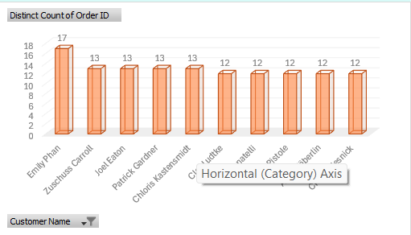 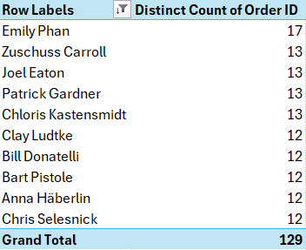

We found out our top 10 clients by analyzing the number of orders

Recommendation:

We encourage our promotional campaigns to be based on these clients’ interests for better targeting.

## Strength and weakness points

### segments of customers drive the most sales by category

We found that consumer segment has the higher sales & technology category of products is our strong selling point.

Recommendation:

* **Product Bundling:** Since our strong selling point is technology, bundle high-performing tech products with complementary products that appeal to this consumer segment. This creates more value for them while also increasing the average transaction size.
* **Loyalty Programs:** Offer targeted loyalty programs or rewards to increase repeat purchases from this segment. We can create exclusive offers for this group, incentivizing them to make more purchases or refer to others.

### states that generate the most sales percentage\ contribution by region

We found that the two highest regions in contribution of sales percentage were west (31.4%) and east (29.6%).

California contributed by 19.73% followed by New York 13.55%.

Recommendation:

**Strengthen Regional Growth (West and East)**

* **West Region (31.4%)**:
  + **Increase Regional Presence**: Build more localized campaigns, especially in areas where you see growing interest.
  + **Expand Distribution**: Ensure that popular products are well stocked in the West region and that fast delivery services are optimized for the area.
* **East Region (29.6%)**:
  + **Personalize Marketing**: Use data to personalize offers and build a more targeted approach for the East region.
  + **Community Engagement**: Host regional events or sponsor community activities to increase brand visibility and consumer loyalty.

## Performance measures

### the top performing product categories in terms of sales

The highest selling category is technology followed by furniture with office supplies by approximate results.

Recommendation:

**Technology (Highest Selling Category)**

* **Innovative Product Launches**: Continuously introduce new technological products or upgrades to existing ones. The tech market thrives on innovation, so aligning with the latest trends (e.g., AI, smart home devices, wearables) could attract even more sales.
* **Bundling Offers**: Create product bundles that pair popular tech items (e.g., laptops with accessories like mice, keyboards, and headphones) to increase average order value.
* **Seasonal Sales and Promotions**: Leverage tech-centric sales events, such as back-to-school or holiday promotions, to drive higher volumes in this category. Offering discounts or exclusive deals can help capture more attention from tech enthusiasts.
* **Customer Education & Reviews**: Given how tech purchases often come with a learning curve, offer comprehensive guides, reviews, and customer support to help customers make informed decisions and ensure they return for future purchases.

**Furniture (Second Highest Selling Category)**

• HomeOffice Furniture: With the rise of remote work, consider promoting home office furniture as a key growth area. Items like ergonomic chairs, desks, and storage solutions can be marketed to those working from home.

• In**-**Store or Online Experience: Create an interactive shopping experience either in-store (virtual reality tours or showroom setups) or online (3D room planners or augmented reality tools) to help customers visualize how the furniture will look in their homes.

• Partnershipswith Interior Designers: Collaborating with interior designers or influencers who can showcase your products in real homes can boost sales, especially in the premium furniture market.

## Customer experience

### Most used shipping modes by our customers % the average of delivery time

We found that the majority of our customers preferred standard class (about 6 days), followed by second class (about 3 days) and the least used shipping mode was the same day shipping.

Recommendation:

**Enhance Standard Class Shipping (Most Preferred)**

* **Improve Speed and Reliability**: Since standard class is the most popular choice, ensuring that this option consistently delivers on its promise (6 days) is key. If possible, try to improve the delivery time to 4–5 days to offer a faster experience without compromising cost. Regularly communicate with shipping partners to ensure timeliness and reliability.
* **Offer Tracking Options**: Customers prefer transparency about their orders. Provide an easy-to-use tracking system for standard-class shipping, allowing customers to track their orders in real-time. Additionally, send timely updates via SMS or email notifications on the order’s status.

**Evaluate Same-Day Shipping (Least Popular)**

* **Review Pricing and Accessibility**: Since same-day shipping is the least chosen option, it could be due to the high cost or limited accessibility (e.g., only available in certain locations). Consider evaluating if the price point is deterring customers, and if necessary, try offering this option at a lower cost or in specific high-demand areas.